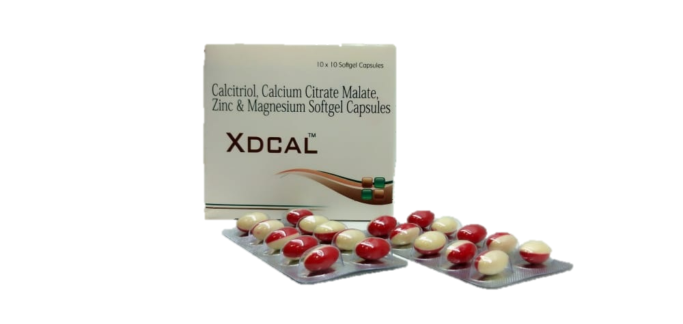  New Calcium delivery system

XDCAL soft gel capsule

Calcitriol 0.25 mcg + Calcium Citrate Malate 500 mg

Elemental Zinc 7.5mg + Elemental Magnesium 50mg

* Calcium Citrate Malate is the calcium salt of citric acid and malic acid.
* Most Bio-available calcium
* Water Soluble

**Indicated For:**

* **Pregnancy and Adolescents**
* **Post-Menopausal Women**
* **Elderly**
* **Adjuvant to Osteoporosis, Osteomalacia & Fractures**
* **Other Calcium deficiency states**

**Absorption:**

* Calcium Citrate Malate is created when the chelating agent Malic acid is added to Calcium Citrate, a compound is created that is 10 times more soluble than Calcium Citrate itself.
* In elderly people, when stomach acid is weak the need for a soluble form of calcium can become critical.

**Menopausal Women:**

* Supplementation with Calcium Citrate Malate is more effective than supplementation with calcium carbonate.

[**N Engl J Med.**](https://www.ncbi.nlm.nih.gov/pubmed/2203965)**1990 Sep 27; 323(13):878-83.**

**Bone Density:**

* Supplementation with Calcium Citrate Malate resulted in significant increases in total body and spinal bone density in adolescent girls which may provide protection against Osteoporotic fracture.

[**Contact us to learn more.**](https://www.mensafutura.com/index.html)

**Mensa Futura Life Sciences**